ST ANDREW’S JUNIOR COLLEGE

JC2 PRELIMINARY EXAMINATIONS
Chemistry  Higher 2 |  |  | 9647/01
Paper 1 Multiple Choice |  |  | 21 September 2010  1 hour
Additional Materials: Multiple Choice Answer Sheet, Data Booklet
READ THESE INSTRUCTIONS FIRST

Write in soft pencil. Do not use staples, paper clips, highlighters, glue or correction fluid.

There are 40 questions on this paper. Answer all questions. For each question there are four possible answers A, B, C and D. Chose the one you consider correct and record your choice in soft pencil on the separate Answer Sheet.

Each correct answer will score one mark. A mark will not be deducted for a wrong answer. Any rough working should be done in this booklet.

This document consists of 21 printed pages including this page.
Section A

For each question, there are four possible answers: A, B, C and D. Choose the one you consider correct and record your choice.

1. | 10 cm³ of a gaseous hydrocarbon was exploded with 100 cm³ of oxygen. The volume of gas remaining at the end of the combustion was 75 cm³. After shaking these gases with aqueous sodium hydroxide, the final volume of gas remaining was 25 cm³. All volumes were measured at room temperature and pressure. Deduce the molecular formula of the hydrocarbon.
 | A | C₂H₄
 | B | C₂H₆
 | C | C₅H₁₀
 | D | C₅H₁₂
2. | In acidic condition, MnO₄⁻ ions are reduced to Mn²⁺ ions whereas in neutral condition, they are reduced to MnO₂.  25.0 cm³ of Fe²⁺ solution is oxidised by 15.0 cm³ of MnO₄⁻ solution in acidic condition. What volume of MnO₄⁻ solution is required to oxidise 25.0 cm³ of Fe²⁺ solution in neutral condition?
 | A | 7.5 cm³
 | B | 9.0 cm³
 | C | 25.0 cm³
 | D | 30.0 cm³
3. | Which of the following property will increase continuously across Period 2?
 | A |  | Maximum oxidation number in oxide
 | B |  | First Ionisation Energy
 | C |  | Nuclear charge
 | D |  | Atomic radius
4. | Which graph incorrectly describes the behaviour of a fixed mass of an ideal gas?
 | A | constant P  V/T  T |  |  |  |  |  | C |  |  |  | T  1/P  constant V
 | B | constant T  P  V |  |  |  |  |  | D |  |  |  | V  pV  constant T
5. | Phosphorus oxides exist in many different intermediate forms. Two forms of phosphorus oxides, P₄O₉ and P₄O₁₀, are shown below.  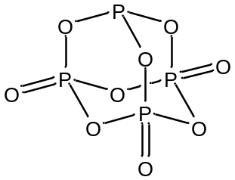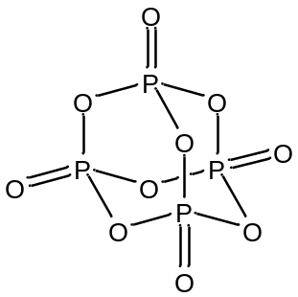  P₄O₉ P₄O₁₀  Which of the following statements is true?
 | A | The phosphorus atoms of both oxides can act as a ligand.
 | B | The phosphorus atoms of both oxides do not have lone pair of electrons.
 | C | The phosphorus atoms of both oxides have the same oxidation state.
 | D | The phosphorus atoms of both oxides have electron pairs that are arranged tetrahedrally.
6. | Which of the following sets contains one ionic, one simple molecular, and one macromolecular substance?
 | A | Silicon, aluminium oxide and silicon oxide
 | B | Iodine, hydrogen bromide and silicon oxide
 | C | Water, lithium aluminium hydride, diamond
 | D | Carbon dioxide, aluminium chloride and graphite
7. | When solid ammonium nitrate dissolves in water, the temperature of the water drops.  Which of the following conclusions can be made from the above statement?
 | A | The NH₄⁺ ions can form hydrogen bonds with H₂O molecules.
 | B | The dissolution is an exothermic process.
 | C | The lattice energy of ammonium nitrate is more exothermic than the hydration energy of its ions.
 | D | The standard enthalpy change of formation of ammonium nitrate is endothermic.
8. | Given the above information, what is the enthalpy change for the following reaction?  Fe₂O₃ (s) + 3 C (s) → 2 Fe (s) + 3 CO (g)
  Compound | ∆H_{f} / kJ mol⁻¹
  Fe₂O₃ (s) | -825
  CO (g) | -110
 | A | -715 kJ mol⁻¹ |  |  |  |  |  | C |  |  |  | +495 kJ mol⁻¹
 | B | +715 kJ mol⁻¹ |  |  |  |  |  | D |  |  |  | +1155 kJ mol⁻¹
9. | Nitrogen monoxide reacts with hydrogen as shown below:  2NO(g) + 2H₂(g) → N₂(g) + 2H₂O(g)  Experiments were carried out to study the rate of reaction at a constant temperature.  Which of the following statements is correct?
  Experiment | 1 | 2 | 3 | 4
  Initial partial pressure of NO/atm | 0.20 | 0.20 | 0.40 | 0.80
  Initial partial pressure of H₂/atm | 0.40 | 0.80 | 0.80 | 0.20
  Relative rate | 1 | 2 | 8 | x
 | A | The order of reaction with respect to NO is 1.
 | B | The overall order of reaction is 2.
 | C | The value of x is 8.
 | D | The value of x is 4.
10. | If the rate of decay of a radioactive isotope Z decreases from 1800 counts per minute to 180 counts per minute in 1 week, what is its approximate half life?
 | A | 20 h |  |  |  |  |  | C |  |  |  | 50 h
 | B | 40 h |  |  |  |  |  | D |  |  |  | 100 h
11. | The equilibrium between N₂O₄ and NO₂ is represented by the following equation at 298 K.  N₂O₄ (g) 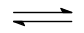 2NO₂ (g)  If the total pressure of the equilibrium mixture is  and the degree of dissociation of N₂O₄ (g) is , what is the partial pressure of NO₂ (g) under these conditions?
 | A | 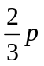 |  |  |  |  |  | C |  |  |  | 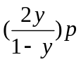
 | B | 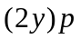 |  |  |  |  |  | D |  |  |  | 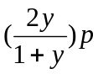
12. | The graph below shows the pH change when 25.0 cm³ of 0.100 mol dm⁻³ aqueous  HCl was titrated against 0.100 mol dm⁻³ methylamine. The K_{b} of methylamine is 4.37 x 10⁻⁴ mol dm⁻³. What is the pH of the solution when 12.5 cm³ of methylamine was added?  pH  Volume of methylamine / cm³  25  12.5
 | A | 1.48 |  |  |  |  |  | C |  |  |  | 3.36
 | B | 2.90 |  |  |  |  |  | D |  |  |  | 10.6
13. | 2.0 cm³ of 0.500 mol dm⁻³ of sodium hydroxide is added separately to 1.0 dm³ of 0.200 mol dm⁻³ of magnesium nitrate and calcium nitrate at 298 K.  K_{sp}(magnesium hydroxide) = 1.0 x 10⁻¹¹ mol³ dm⁻⁹  K_{sp}(calcium hydroxide) = 4.0 x 10⁻⁶ mol³ dm⁻⁹  Which of the following shows the correct observation for the above reactions?
 |  |  | Magnesium hydroxide |  |  | Calcium hydroxide
 | A |  | Precipitated |  |  | Precipitated
 | B |  | Precipitated |  |  | Not precipitated
 | C |  | Not precipitated |  |  | Precipitated
 | D |  | Not precipitated |  |  | Not precipitated
14. | Which of the following statements is true regarding the following cell under standard conditions?  Cu (s) / Cu²⁺(aq) // Fe³⁺(aq), Fe²⁺(aq) / Pt(s)
 | A | The voltage across the cell is 1.11 V.
 | B | Electrons flow from the copper electrode to the platinum electrode.
 | C | The copper electrode is the cathode.
 | D | The platinum electrode is the negative terminal.
15. | Aluminum can be obtained from electrolysis of aluminum oxide. A current of 350 kA was passed through the electrolytic cell for 8 hours. What is the mass of aluminum obtained?
 | A | 9.68 kg |  |  |  |  |  |  | C |  |  | 2820 kg
 | B | 28.2 kg |  |  |  |  |  |  | D |  |  | 940 kg
16. | Which of the following sets contains a basic, an acidic and an amphoteric oxide?
 | A | SiO₂ |  | Al₂O₃ |  |  |  |  |  |  | P₄O₆
 | B | MgO |  | SiO₂ |  |  |  |  |  |  | SO₃
 | C | Na₂O |  | Al₂O₃ |  |  |  |  |  |  | P₄O₁₀
 | D | SO₂ |  | SiO₂ |  |  |  |  |  |  | P₄O₁₀
17. | Which property when plotted against period 3 elements gives the following graph?  Atomic number
 | A | Ionic radii |  |  |  |  |  |  | C |  |  | Second ionisation energy
 | B | Electrical conductivity |  |  |  |  |  |  | D |  |  | Melting point
18. | Which of the following compounds is not produced when magnesium nitrate is heated?
 | A | Magnesium oxide
 | B | Oxygen
 | C | Nitrogen dioxide
 | D | Nitrogen
19. | Which of the following correctly describes the reactions of the Group II metals with water?
 |  |  | Be |  | Mg |  |  |  |  |  |  |  |  | Ca
 | A |  | Reacts with steam. |  | Reacts with cold water. |  |  |  |  |  |  |  |  | Reacts with cold water.
 | B |  | Reacts with steam. |  | Reacts with steam. |  |  |  |  |  |  |  |  | Reacts with cold water.
 | C |  | No reaction with water. |  | Reacts readily with steam. |  |  |  |  |  |  |  |  | Reacts readily with cold water.
 | D |  | No reaction with water. |  | Reacts readily with cold water. |  |  |  |  |  |  |  |  | Reacts with steam.
20. | Which of the following properties shows an increasing trend for the Group VII halogens and their hydrogen halides?
 | A | Oxidising power of Cl₂, Br₂, I₂
 | B | Thermal stability of HCl, HBr, HI
 | C | Boiling point of HCl, HBr, HI
 | D | Reducing power of HI, HBr, HCl
21. | Two different complexes, X and Y, can be obtained by reacting aqueous cobalt(III) chloride with ammonia under various conditions. Different proportions of chloride are precipitated when each of the complexes is treated with aqueous silver nitrate.  Which of the following shows the correct structures of X and Y?
   | Formula | Colour of solid | Number of moles of AgCl precipitated per mole of complex | Does the complex have a dipole moment?
  X | CoCl₃(NH₃)₅ | violet | 2 | yes
  Y | CoCl₃(NH₃)₄ | violet | 1 | yes
 |  |  | X |  |  |  | Y
 | A |  | 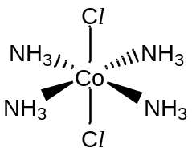 |  |  |  | 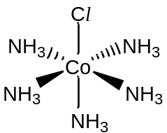
 | B |  | 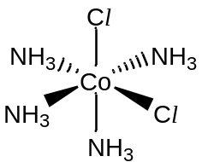
 | C
 | D
22. | How many stereoisomers are possible for the following compound?  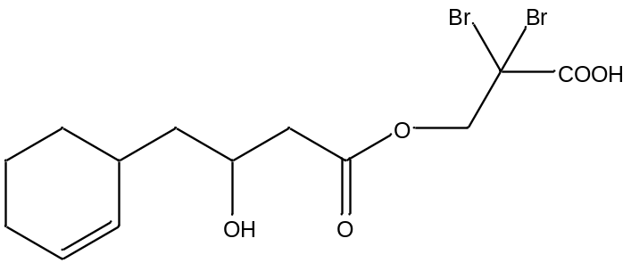
 | A |  | 0 |  |  |  |  |  |  | C |  |  | 4
 | B |  | 2 |  |  |  |  |  |  | D |  |  | 8
23. | The Russian composer Borodin was also a research chemist who discovered a reaction in which two ethanal molecules combine to form a compound commonly known as aldol (reaction I).  Aldol forms another compound on heating (reaction II).  I 2CH₃CHO → CH₃CH(OH)CH₂CHO  II CH₃CH(OH)CH₂CHO → CH₃CH=CHCHO + H₂O  Which one of the following would be produced when acetone, CH₃COCH₃ undergoes the same reactions?
 | A |  | CH₃CH=CHCOCH₃ |  |  |  |  |  |  | C |  |  | CH₃COCH=C(CH₃)₂
 | B |  | C(CH₃)₂=CHCHO |  |  |  |  |  |  | D |  |  | CH₃CH=CHCH₃
24. | Which sequence shows the compounds in increasing order of pKa values?  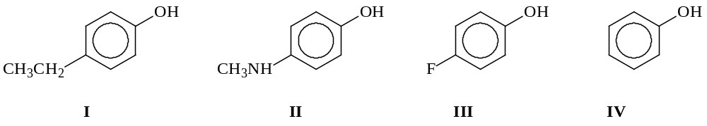
 | A |  | I, II, III, IV |  |  |  |  |  |  | C |  |  | II, I, III, IV
 | B |  | IV, II, III, I |  |  |  |  |  |  | D |  |  | III, IV, I, II
25. | A hexapeptide gave the following peptide residues upon partial hydrolysis:  Val-His, Leu-Ala, Val-Phe, His-Val and Phe-Leu.  What is the structure of the hexapeptide?
 | A |  | Val-His-Val-Phe-Leu-Ala |  |  |  |  |  |  | C |  |  | Phe-Leu-Ala -His-Val-Phe
 | B |  | Ala-Leu-Phe-Val-His-Val |  |  |  |  |  |  | D |  |  | His-Val-Phe-Leu-Ala-Val
26. | A compound U has all the following properties.  - It reacts with aqueous Na₂CO₃  - It gives a brick red precipitate with Fehling’s solution.  - It gives a green colouration with hot acidified K₂Cr₂O₇.  What could U be?
 | A |  | 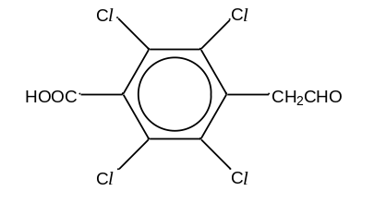 |  |  |  |  |  |  | C |  |  | 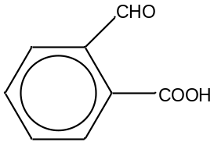
 | B |  | 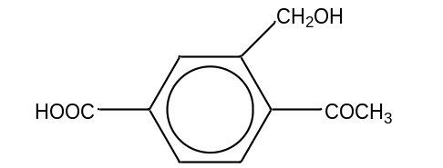 |  |  |  |  |  |  | D |  |  | 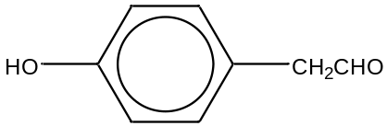
27. | Which of the following organic compounds would give a yellow precipitate on heating with aqueous alkaline iodine?
 | A |  | 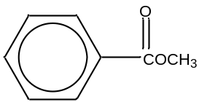 |  |  |  |  |  |  | C |  |  | 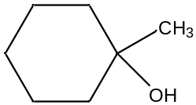
 | B |  | 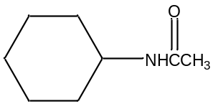 |  |  |  |  |  |  | D |  |  | 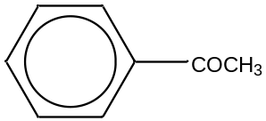
28. | Which of the following compounds, on complete oxidation with hot acidified potassium manganate(VII), would give two organic compounds?
 | A |  | (CH₃)₂C=CHCH₂CH₂CH=CH₂ |  |  |  |  |  |  | C |  |  | CH₃(CH₂)₂CH=CH(CH₂)₂CH₃
 | B |  | CH₃(CH₂)₄CH=CHCH₂OH |  |  |  |  |  |  | D |  |  | C₆H₅CH₂CH₃
29. | The structure of Q is as shown:  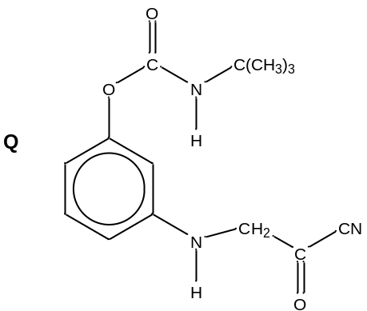  What would be formed by prolonged boiling of Q with aqueous sodium hydroxide?
 | A |  | 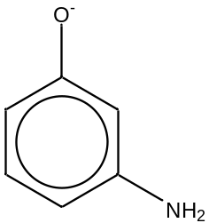 |  |  |  |  |  |  | C |  |  | 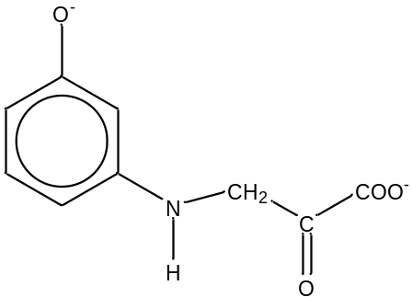
 | B |  | 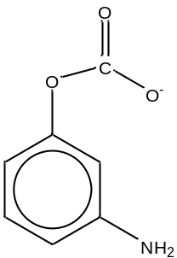 |  |  |  |  |  |  | D |  |  | 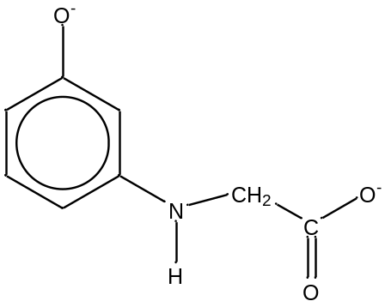
30. | The two-stage reaction sequence given below shows a possible mechanism for the reaction between hydroxide ion and an organic compound:  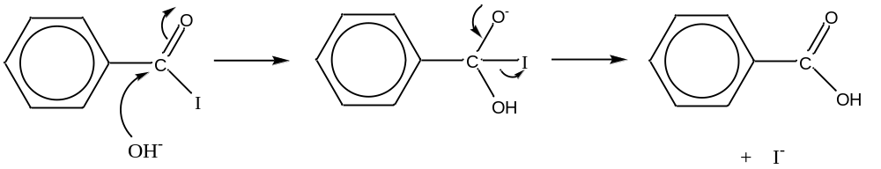  The overall reaction should be classified as
 | A |  | Electrophilic addition
 | B |  | Electrophilic substitution
 | C |  | Nucleophilic addition
 | D |  | Nucleophilic substitution

Section B

For each of the questions in this section, one or more of the three numbered statements, 1 to 3 may be correct.
Decide whether each of the statements is or is not correct (you may find it helpful to put a tick against the statements that you consider to be correct).
The responses A to D should be selected on the basis of

A | B | C | D
1, 2, and 3 are correct | 1 and 2 only are correct | 2 and 3 only are correct | 1 only is correct

No other combination of statements is used as a correct response.

31. | Nitrogen oxides (NO_{x}) can be formed from the reaction of nitrogen with oxygen in the engines of cars. It can dissolve in water to form nitric acid which causes acid rain. Which of the following statements explain the chemical structures of NO, NO₂ and NO₃⁻ ?
 | 1 |  | N atom in NO₃⁻ is sp² hybridised.
 | 2 |  | NO and NO₂ contain an unpaired electron.
 | 3 |  | NO and NO₂ are linear and have no net dipole moment.
32. | Which of the following might be reasons why an endothermic reaction can be spontaneous?
 | 1 |  | The temperature is very high.
 | 2 |  | The increase in entropy is very large.
 | 3 |  | The change in Gibbs free energy of the reaction is positive.
For each of the questions in this section, one or more of the three numbered statements, 1 to 3 may be correct.
Decide whether each of the statements is or is not correct (you may find it helpful to put a tick against the statements that you consider to be correct).
The responses A to D should be selected on the basis of

A | B | C | D
1, 2, and 3 are correct | 1 and 2 only are correct | 2 and 3 only are correct | 1 only is correct

No other combination of statements is used as a correct response.

33. | To monitor the rate of reaction of 2X(g) + Y(g) → X₂Y(g), two experiments were conducted and the results were shown in the tables below.  Experiment I : 2 dm³ of X was reacted with 20 dm³ of Y  Experiment II : 2 dm³ of X was reacted with 10 dm³ of Y  What information can be deduced from the experiments?
  Time/ min | 0 | 10 | 20 | 40 | 600
  Volume of X₂Y/ dm³ | 0 | 0.25 | 0.50 | 0.75 | 1
  Experiment No. | Relative Rate
  I | 4
  II | 1
 | 1 |  | The half life of experiment I is constant.
 | 2 |  | The order of reaction is first order with respect to X.
 | 3 |  | The order of reaction is first order with respect to Y.
For each of the questions in this section, one or more of the three numbered statements, 1 to 3 may be correct.
Decide whether each of the statements is or is not correct (you may find it helpful to put a tick against the statements that you consider to be correct).
The responses A to D should be selected on the basis of

A | B | C | D
1, 2, and 3 are correct | 1 and 2 only are correct | 2 and 3 only are correct | 1 only is correct

No other combination of statements is used as a correct response.

34. | Which of the following combinations of substances would give a buffer solution?
 | 1 | 15.0 cm³ of 0.05 mol dm⁻³ HNO₃ and 25.0 cm³ of 0.1 mol dm⁻³ CH₃NH₂
 | 2 | 20.0 cm³ of 0.2 mol dm⁻³ CH₃COOH and 10.0 cm³ of 0.5 mol dm⁻³ NaOH
 | 3 | 25.0 cm³ of 0.1 mol dm⁻³ HCl and 50.0 cm³ of 0.05 mol dm⁻³ NH₃
35. | Which of the following species will be able to oxidise iodide ions to iodine?
 | 1 | Cu²⁺
 | 2 | Fe³⁺
 | 3 | Co³⁺
For each of the questions in this section, one or more of the three numbered statements, 1 to 3 may be correct.
Decide whether each of the statements is or is not correct (you may find it helpful to put a tick against the statements that you consider to be correct).
The responses A to D should be selected on the basis of

A | B | C | D
1, 2, and 3 are correct | 1 and 2 only are correct | 2 and 3 only are correct | 1 only is correct

No other combination of statements is used as a correct response.

36. | Astatine (At) is a Group VII element. Its properties are not easily studied due to its short half life and low natural abundance. However, its properties can be deduced from the trends of other Group VII elements. Which of the following statements about astatine are likely to be correct?
 | 1 | HAt is a stronger acid compared to HCl.
 | 2 | At₂ disproportionates in cold dilute sodium hydroxide to yield AtO₃⁻ and At ⁻ as major products.
 | 3 | Potassium astatide forms a precipitate with silver nitrate quickly and can dissolve in dilute aqueous ammonia solution.
For each of the questions in this section, one or more of the three numbered statements, 1 to 3 may be correct.
Decide whether each of the statements is or is not correct (you may find it helpful to put a tick against the statements that you consider to be correct).
The responses A to D should be selected on the basis of

A | B | C | D
1, 2, and 3 are correct | 1 and 2 only are correct | 2 and 3 only are correct | 1 only is correct

No other combination of statements is used as a correct response.

37. | Cyproterone is a common component used in hormone therapy.  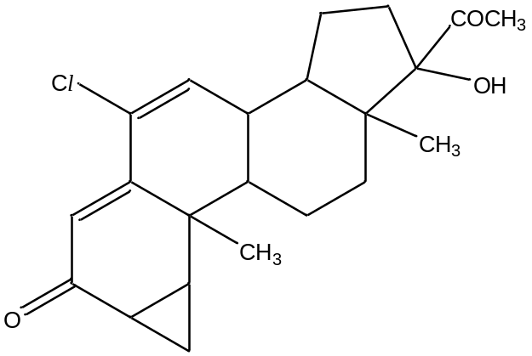  Which of the following statements about Cyproterone are correct?
 | 1 | It forms a yellow precipitate with alkaline aqueous iodine.
 | 2 | It possesses 8 chiral carbons.
 | 3 | It forms a dicarboxylic acid when reacted with hot acidified potassium dichromate(VI).
For each of the questions in this section, one or more of the three numbered statements, 1 to 3 may be correct.
Decide whether each of the statements is or is not correct (you may find it helpful to put a tick against the statements that you consider to be correct).
The responses A to D should be selected on the basis of

A | B | C | D
1, 2, and 3 are correct | 1 and 2 only are correct | 2 and 3 only are correct | 1 only is correct

No other combination of statements is used as a correct response.

38. | Which of the following reagents can be used to distinguish between the two compounds shown below?  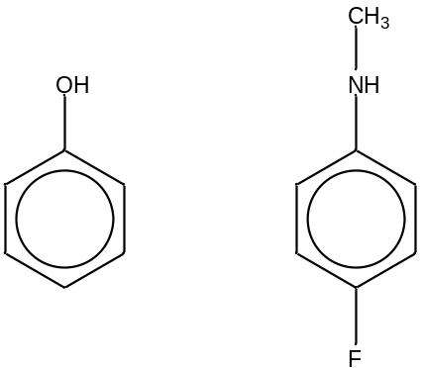
 | 1 | Aqueous NaOH
 | 2 | Aqueous bromine
 | 3 | Aqueous alkaline iodine
For each of the questions in this section, one or more of the three numbered statements, 1 to 3 may be correct.
Decide whether each of the statements is or is not correct (you may find it helpful to put a tick against the statements that you consider to be correct).
The responses A to D should be selected on the basis of

A | B | C | D
1, 2, and 3 are correct | 1 and 2 only are correct | 2 and 3 only are correct | 1 only is correct

No other combination of statements is used as a correct response.

39. | Propene is found to react with chlorine in the presence of aqueous sodium bromide and sodium nitrate. Which of the following are not possible products of the reaction?
 | 1 | 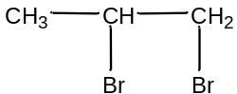
 | 2 | 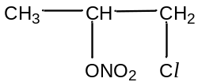
 | 3 | 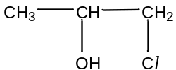
40. | Substance A is used as a starting material for a class of anti-bacterial drugs known as quinolones. Which of the following statements about A are correct?  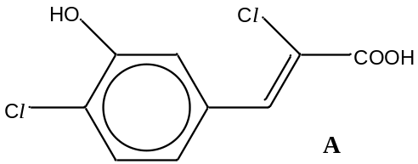
 | 1 | 1 mole of A reacts with PCl₅ to give 1 mole of HCl.
 | 2 | 1 mole of A reacts with Na metal to give 1 mole of H₂.
 | 3 | 1 mole of A reacts with CaCO₃ to give 1 mole of CO₂.
******** End of Paper ********

